**Experiment 14 - Puppet**

| Roll No. | 37 |
| --- | --- |
| Name | Mikil Lalwani |
| Class | D15-B |
| Subject | DevOps Lab |
| LO Mapped | LO1: To understand the fundamentals of DevOps engineering and be fully proficient with DevOps terminologies, concepts, benefits, and deployment options to meet your business requirements.  LO6: To Synthesize software configuration and provisioning using Ansible/Puppet. |
|

**Aim**:

To provision a LAMP/MEAN Stack using Puppet Manifest.

**Introduction**:

What is the LAMP Stack?

The widely popular LAMP stack is a set of open-source software used for web application

development.

For a web application to work smoothly, it has to include an operating system, a web server, a

database, and a programming language. The name LAMP is an acronym of the following

programs:

➔ Linux Operating System

➔ Apache HTTP Server

➔ MySQL database management system

➔ PHP programming language

Each represents an essential layer of the stack, and together they can create a database-driven and

dynamic website.

The illustration below can help visualize how the layers stack together:

Linux

Linux is the operating system layer and the backbone of the LAMP stack.

All the other components of the stack run on top of this foundation. You can efficiently manage

the rest of the stack components on different operating systems such as Windows, macOS, and

others. However, Linux has become the front-runner for web development not just because it is

open-source, but also due to its flexibility, customization, and easy-to-use technology.

Also, the programming language and database management used in developing a website may

dictate the platform you choose to build it on. PHP and MySQL are better suited for Linux. On

the other hand, SQL, ASP.NET, and ASP work more efficiently on Windows.

Apache

HTTP Server is a web server software that runs on top of the Linux operating system.

It is the most widely used server, powering more than half of the websites on the internet. The

role of the web server is to process requests and transmit information through the internet, using

HTTP.

An alternative to Apache is NGINX, a web server whose popularity has been continually

increasing since 2008. Whether you go for one or the other depends on what kind of material you

want to serve on a webpage, as well as the hosting.

NGINX is a better choice for static content. When it comes to dynamic content, there is a minor

difference in performance between the two. Also, Apache is commonly used by shared hosting

users, whereas NGINX is mainly used for virtual private servers, dedicated hosting, or cluster

containers.

MySQL

Note: SQL (Structured Query Language) is the most prevalent query language out there. A query

is what we call a request for information or data stored in your database table.

MySQL earned its reputation as an acclaimed database system as it supports SQL and relational

tables. By doing so, it makes it much easier to establish dynamic enterprise-level databases.

PHP

PHP (Hypertext Preprocessor) is a programming language that has the role of combining all the

elements of the LAMP stack and allows the website or web application to run efficiently. In

short, when a visitor opens the webpage, the server processes the PHP commands and sends the

results to the visitor’s browser.

PHP is the fourth layer of the original stack because it interacts exceptionally well with MySQL.

It is commonly used for web development because it is a dynamically typed language, making it

fast and easy to work with. This feature may be especially appealing if you are a beginner. The

reason why PHP is so convenient to use is that it can be embedded into HTML enabling to jump

in and out of it as you wish.

In the LAMP stack, the P can also refer to two other programming languages – Perl or Python.

All three are simple, yet useful, dynamic tools for creating environments in which you can

successfully develop applications. Nowadays, there is a wide variety of scripting languages to

choose from, including JavaScript, Ruby, and many more.

1. To test your cluster setup, run this command -

sudo /opt/puppetlabs/bin/puppet agent --test

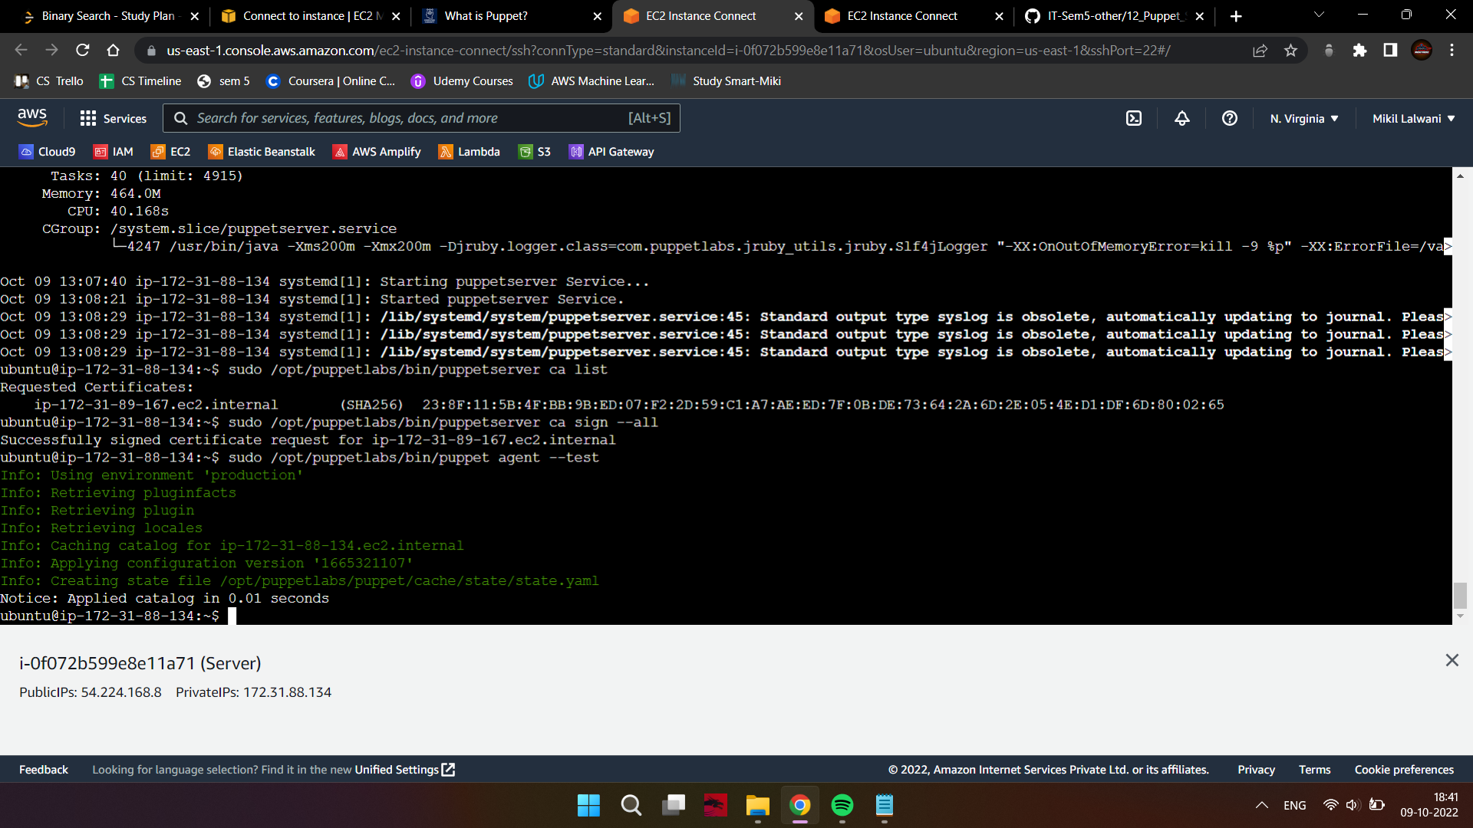

If the output is normal, you can proceed.

1. Change directories to the production folder

cd /etc/puppetlabs/code/environments/production/manifests

1. Use nano to create a new lamp.pp file.

sudo nano lamp.pp

1. Add this code to the file which will install all necessary dependencies and provision the stack. You can obtain this code from here.

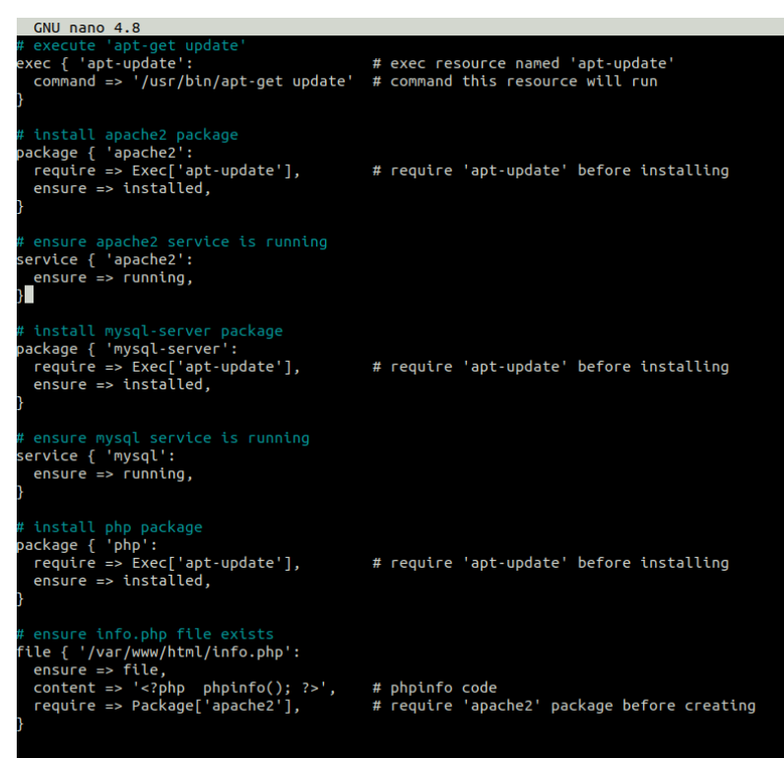

1. Change the directory to the bin folder of puppetlabs where the puppet executable is present.

cd /opt/puppetlabs/bin

1. Use puppet apply to apply the scripts.

./puppet apply

/etc/puppetlabs/code/environments/production/manifests/lamp.pp

1. Once done, go back to the EC2 Console, copy the public IP address of the client machine, and put it in the browser. The URL is - http://ip_address_of_your_client/info.php

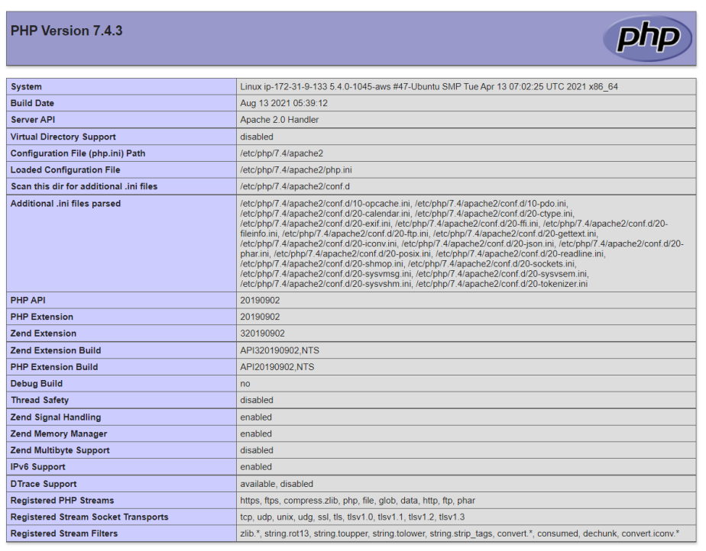

**Conclusion:**

Thus, we learned what a LAMP stack is and learned how to provision it using puppet scripts.